Operation Manual

HMGTU-200kVA/500kV
AC Hipot Tester

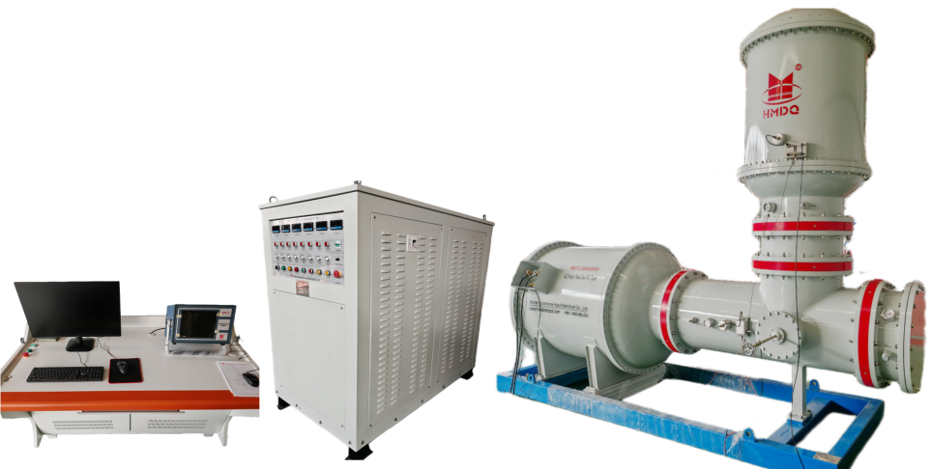

WUHAN GOLDHOME HIPOT ELECTRICAL CO., LTD.
Tel：+86-18627130886 Fax：+86-27-84620387
Email: goldhome01@cablehipot.com Web: www.hvcablehipot.com
Add: No. A25-1, Huading Mould Industrial Park, Hannan, Wuhan, Hubei, China

Scope of application

The test set is suitable for factory testing of voltage levels below 500kV, cable insulation withstand voltage, and partial discharge measurement.

Installation and usage conditions

- Altitude: No requirements for fully enclosed testing equipment
- Environmental temperature: -10℃~+40℃
- Relative humidity of air: No requirements for fully enclosed testing equipment
- Have a good grounding system.
- Installation and use location: indoor use
- The waveform of the power supply voltage is a sine wave, with waveform distortion ≤ 3%
- Independent power supply, three-phase five wire power supply, grounding, spatial partial discharge background<1PC
- There is a reliable grounding with a grounding resistance＜0.5Ω.

Basic technical requirements

The complete testing set mainly consists of a control system, a high-voltage power supply system, a test sample interface system, a low-voltage power supply system. Conduct the test in an unshielded environment, with the harmonic component of the test power supply being less than 5%, and the local discharge of the entire system being less than 1pC at rated voltage. The annual leakage rate of each sealed chamber is less than 0.5%.

Configuration of test set

- Operation desk(remote control unit)
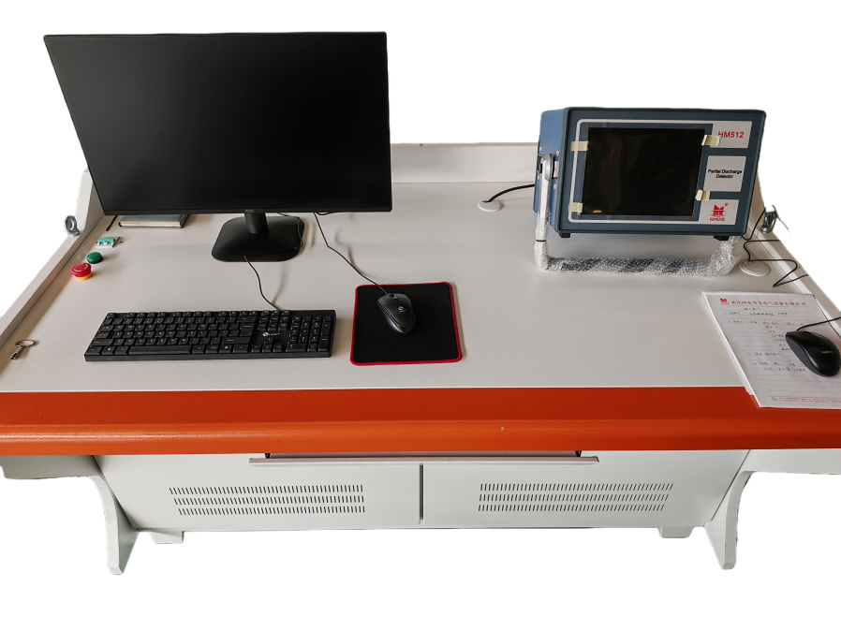
Technical parameters

Model: HMTC-200/500
S/N: 2509052
Input voltage: 220V
Frequency: 50Hz

- Isolation/compensation/voltage regulation cabinet

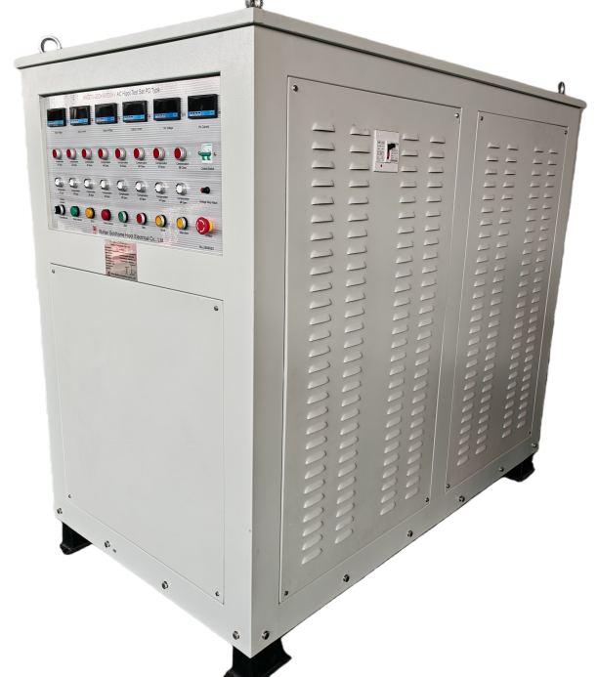

Technical Parameters

Model: HM200kVA
S/N: 2509052
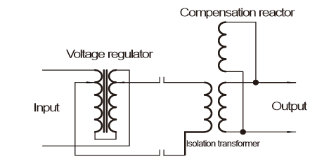
Power Supply: Single phase, 380V/50Hz
Input Capacity: 50kVA
Input Current: 131.5A
Output Capacity:200kVA
Output Voltage: 1000V
Output Current: 200A
Power Insulation Transformer: 50kVA/400V/400V
Electrical Voltage Regulator: 50kVA/400V
Isolation Transformer: 200kVA/400V/1000V
Compensation Reactor: 25kVA/400V*8

- Test Transformer
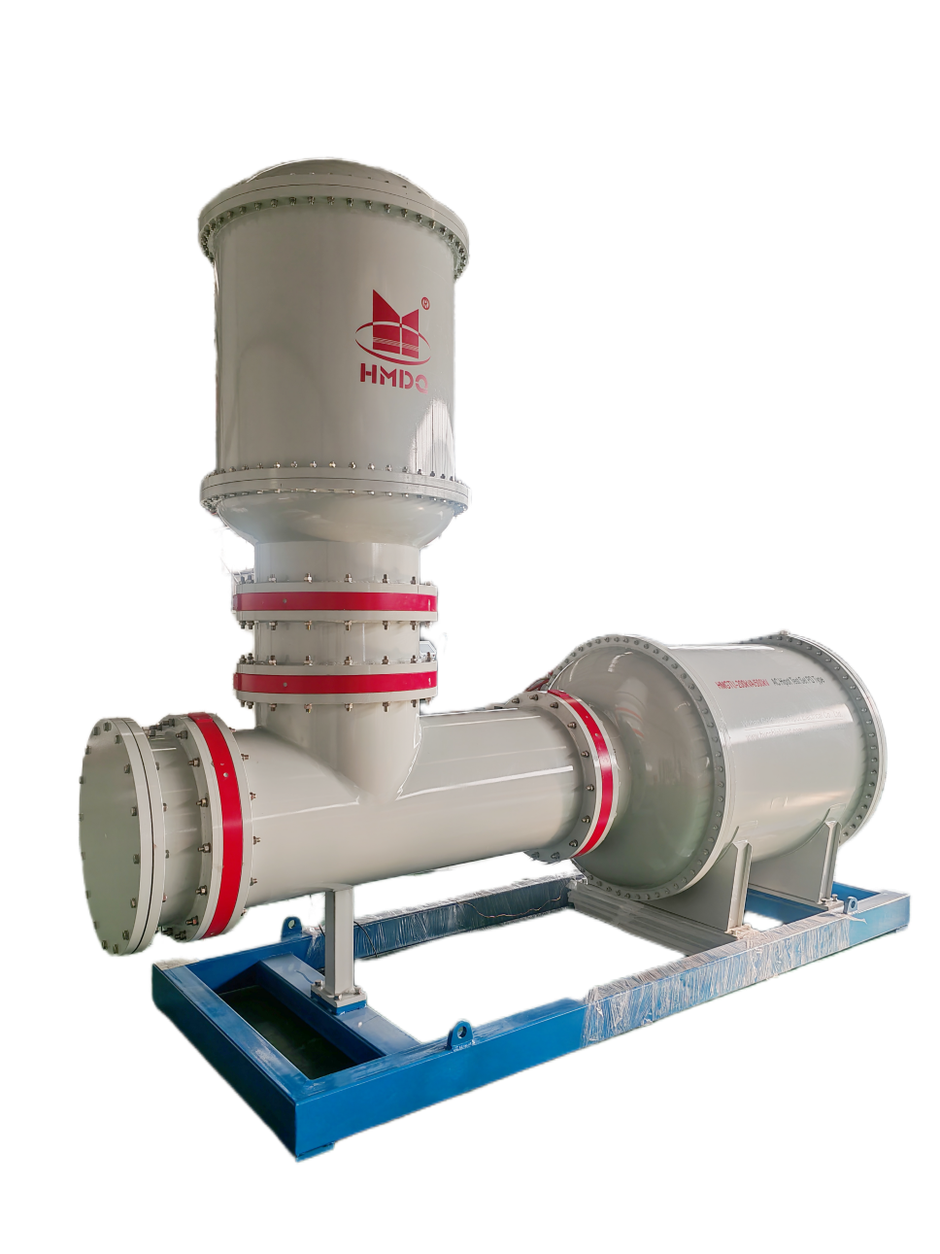
When it is necessary to open the flange, the air pressure in the flange area needs to be reduced to 0, and the air pressure in the transformer body does not need to be reduced.

The maximum pressure difference between the docking flange and the transformer body is 0.7MPa.

During normal testing, the tank pressure is maintained at 0.5±5%MPa.

Technical Parameters

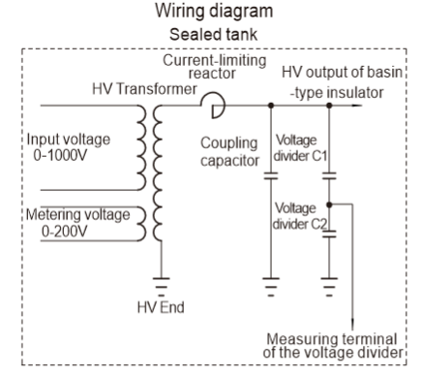
Model:HMGTU-200kVA/500kV
S/N: 2509052
Power Supply: AC 380V/50Hz, Single phase
Rated Capacity: 200kVA
Rated HV: 500kV
Rated HV Current: 400mA
Rated LV: 1000V
Rated LV Current: 200A
Rated Frequency: 50Hz
Insulation Medium: SF6
Inflation pressure: 0.5Mpa
Waveform Distortion rate: ≤3%
Impedance Voltage of test transformer:＜12%
Capacitance of coupling capacitor: 300pF
PD level: ≤1pC at rated
Rated HV current:400mA
Rated LV current:200A
Metering voltage of test transformer: 200V
Accuracy of voltage divider: 1.5%
- Wire Connection

- Operation desk

The power switch and emergency button are on the left hand of the desk.



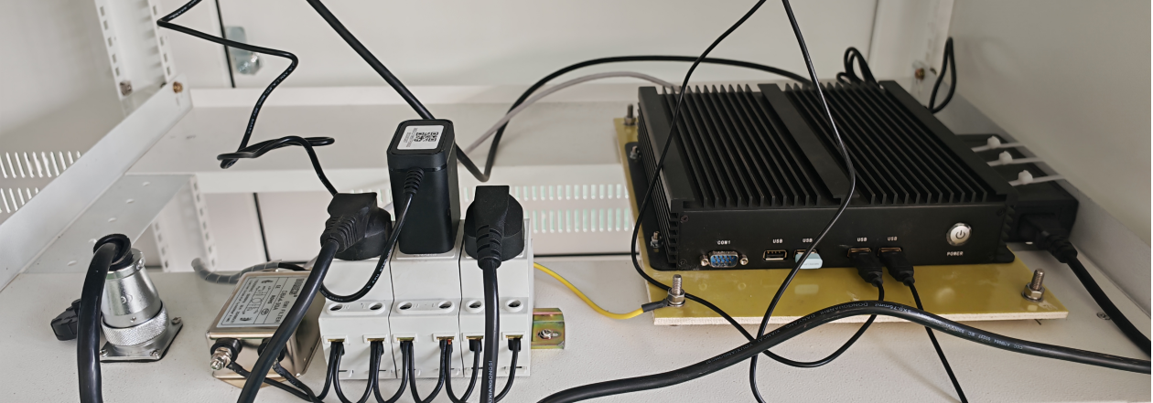
Computer
Power Strip
Aviation Connector
To the cabinet

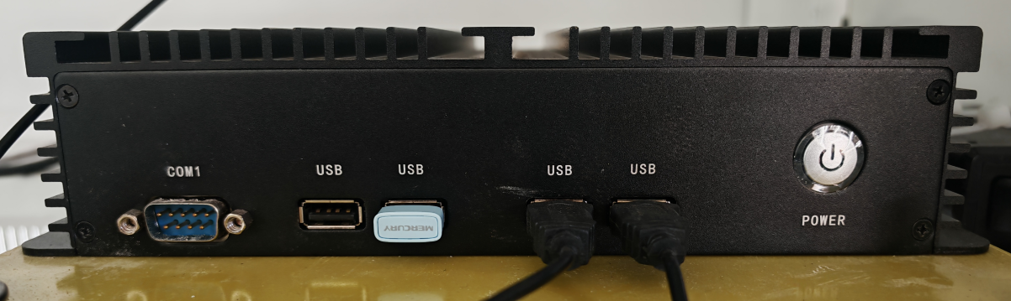

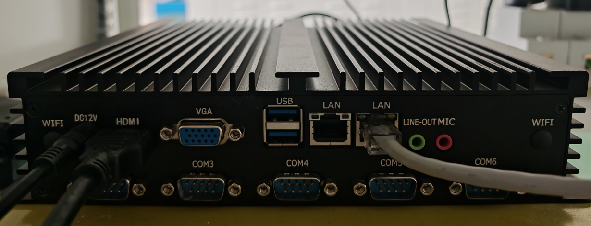
Attention:
Please select the LAN port on the right, as the system presets parameters through this interface

- Isolation/compensation/voltage regulation cabinet
- Power switch on the right hand of the cabinet, it is the power switch for the entire testing system.

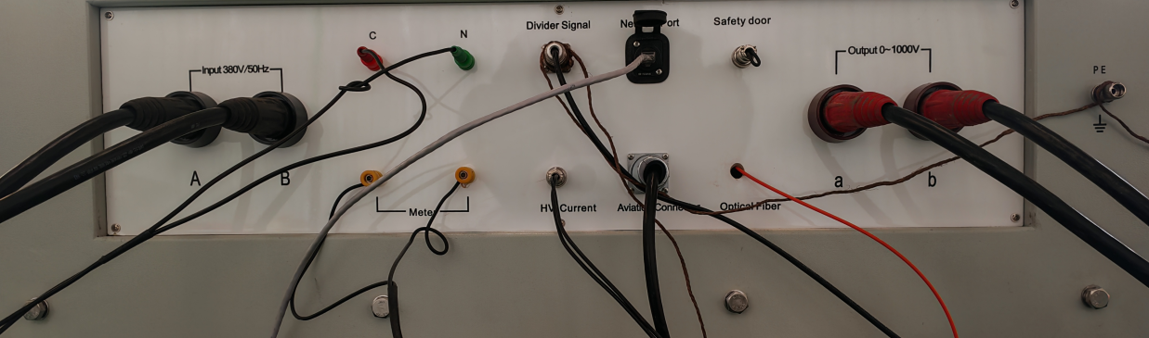

Input A&B: Power supply of the entire system

C&N: Connect with the AC mains

Meter: connect with the meter of test transformer

Divider signal: the HV output signal, connect with the voltage divider

HV current: connect with the test transformer

Aviation connector: connect with the operation desk

Optical fiber: connect with the quick protection box

Output 0~1000V: connect with the input of the test transformer

PE: earthing
- Test Transformer

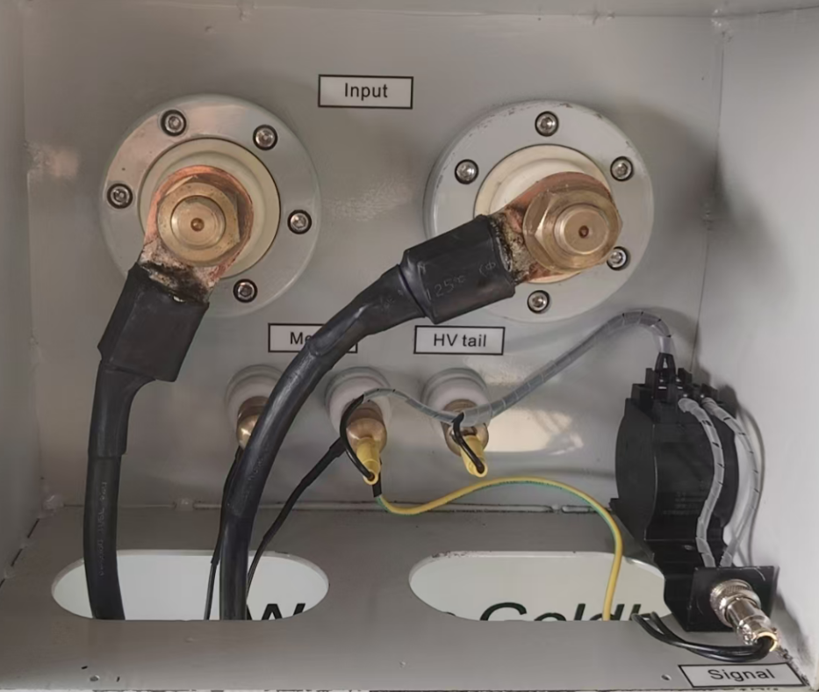

Input: connect with ouput terminals of the cabinet
Meter: connect with the meter of the cabinet
Signal: this is the HV current sigbal, connect with the HV current of the cabinet
PE: earth, at the bottom, picture as below

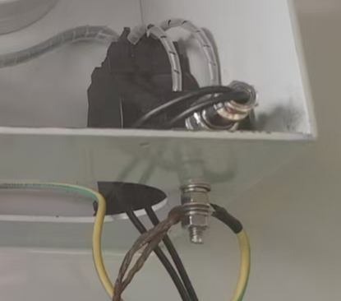
PE

PE: at the base, bottom left corner, picture as below
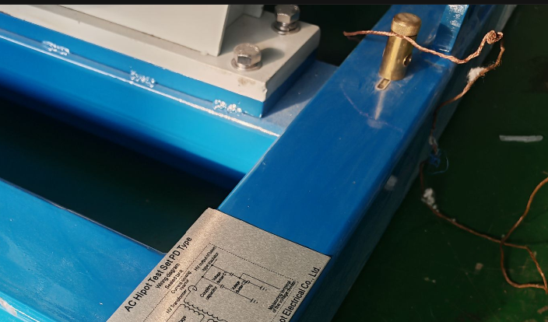
PE

- HV voltage divider
*Quick protection box: When the test sample breaks down, it provides quick protection for the test transformer.

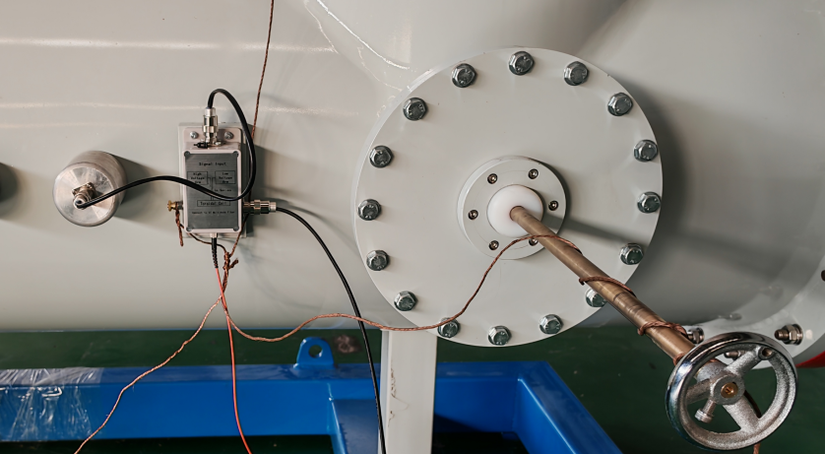
PE
Divider Signal
Connect to Cabinet
Optical Fiber
Connect to Cabinet

Attention: After the pulse calibration is complete, wrap the grounding wire around the pole as shown in the figure above.

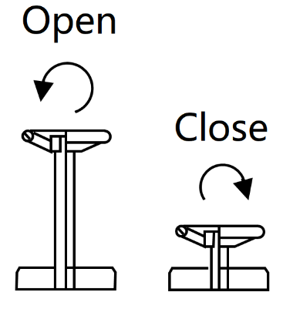
- Coupling capacitor

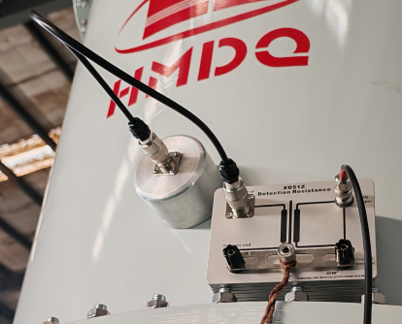
Impedance Matching Unit (for PD signal acquisition)
PD Signal
Connect to
PD tester
PE

- Operation

- Icon of GTU Test and Control System, and main interface:


“SIMATIC”

Note: The actual output voltage is based on the red rectangle “high voltage”

*The meter voltage is the output HV of the test transformer, and it connecting a capacitive voltage divider will have a series resonant rise effect, so the meter voltage will be lower than the actual HV voltage.

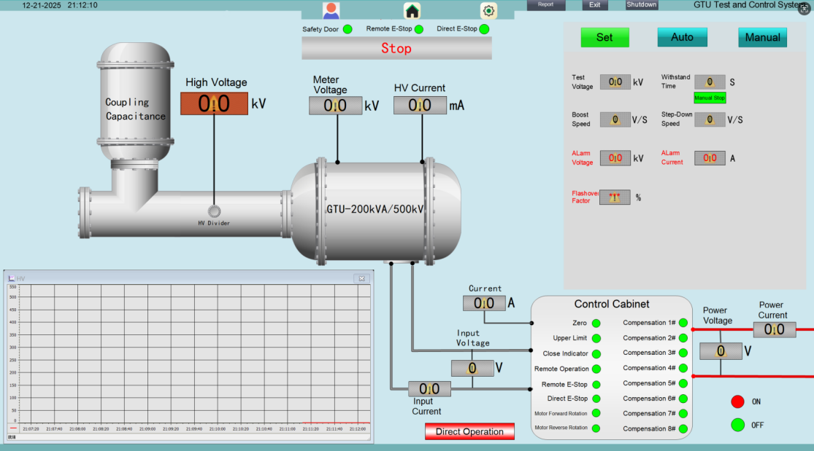
- Parameter setting of the system

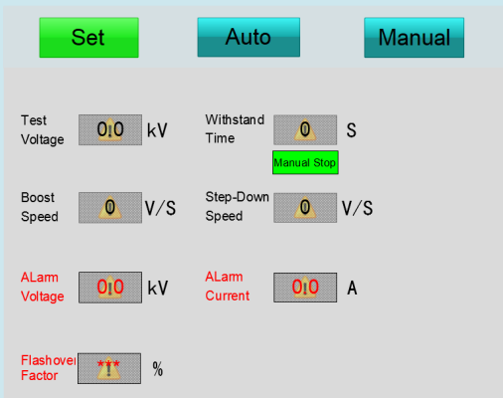

Test voltage: testing voltage you need
Withstand Time: ≤10 minutes at rated current; Continuous operation for≤30 minutes at 2/3 rated current
Boost speed: 100-3000V / S Maximum
Step-down speed: 100-3000V/s Maximum
Alarm voltage: when the testing voltage value is over the setted voltage, the main contactor will be turned off, the setted voltage setting value is 1.1 times of required testing voltage value
Alarm current: when the low voltage current value is over the setted low voltage current value, the main contactor will be turn off, test stops.
Flashover factor: Suggest 30% input, activate protection when voltage drops by more than 30%

- Auto Operation

After completing the parameter settings, go to the fully automatic operation interface

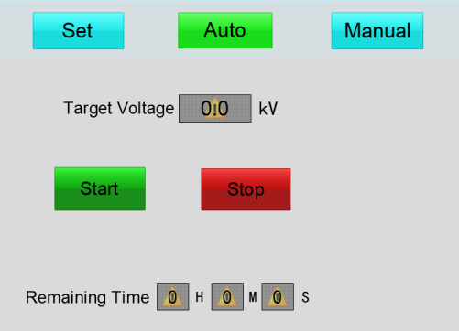

Start: Click Start, the device will automatically boost voltage, automatically start withstand voltage time, and the voltage will automatically drop to 0.
Stop: Used when the experiment needs to be stopped

- Manual Operation

After completing the parameter settings, go to the manual operation interface

Start: start experiment
Boost: voltage rises, single tap for fine-tuning, long press to maintain.
Step-down: voltage falls, single tap for fine-tuning, long press to maintain.
Timing: duration of the experiment
Stop: end experiment

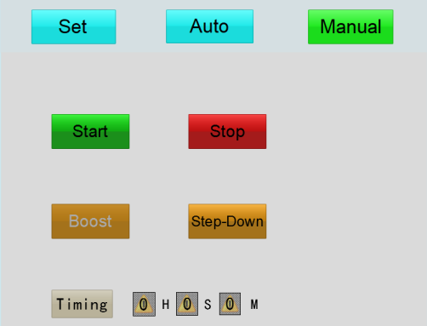

VII-Safety Precautions

1. Set up the testing site according to relevant procedures, connect the equipment cables, and in areas where possible, have designated safety personnel on-site to provide guidance. Connect the grounding terminals of the operating table, transformer, and cabinet to the grounding grid, ensuring a reliable connection.
2. Connect the power cord and turn on the power switch. If you need to approach the test transformer, the test sample, or other connected equipment, please press the "Emergency Stop" button.
3. After power is connected, if the system is not in the zero position, it will automatically return to the zero position.
4. Do not place unrelated items on or around the equipment panel during the test.
5. Check the power supply voltage before powering on.
6. When replacing fuses and accessories, please use the same model as this instrument.
7. Protect this instrument from moisture and oil.
8. Before testing, ensure the tested equipment is powered off and disconnected from other live equipment.

VIII-Transportation and Storage

- Transportation
When transporting the equipment, it is recommended to use our company's instrument packaging wooden crates and shock-absorbing materials to avoid unnecessary damage and losses during transportation.
When transporting equipment without wooden crates, stacking is not permitted.
During transportation, the panel should face upwards.
- Storage
The equipment should be placed in a dry, dust-free, well-ventilated room free of corrosive gases. Stacking is not permitted without wooden crate packaging.
When storing the equipment, the panel should face upwards. Place moisture-proof materials under the equipment to prevent moisture absorption.

IX-Unpacking and Inspection

- Unpacking Precautions
Before unpacking, please ensure that the arrow mark on the outer packaging of the equipment is facing upwards. Do not strike the equipment forcefully when unpacking to avoid damaging it. Remove the equipment from the box, but retain the outer packaging and shock-absorbing materials. This facilitates future use during transportation and storage and also protects the environment.
- Inspection Items
After unpacking, remove the equipment and check the equipment and accessories according to the packing list. If you find any shortages, please contact our company immediately, and we will provide you with services as soon as possible.

